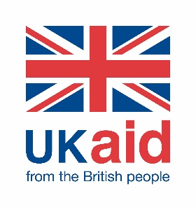

**Evidence digest focus issue: LGBTIQ+ and disability inclusion**

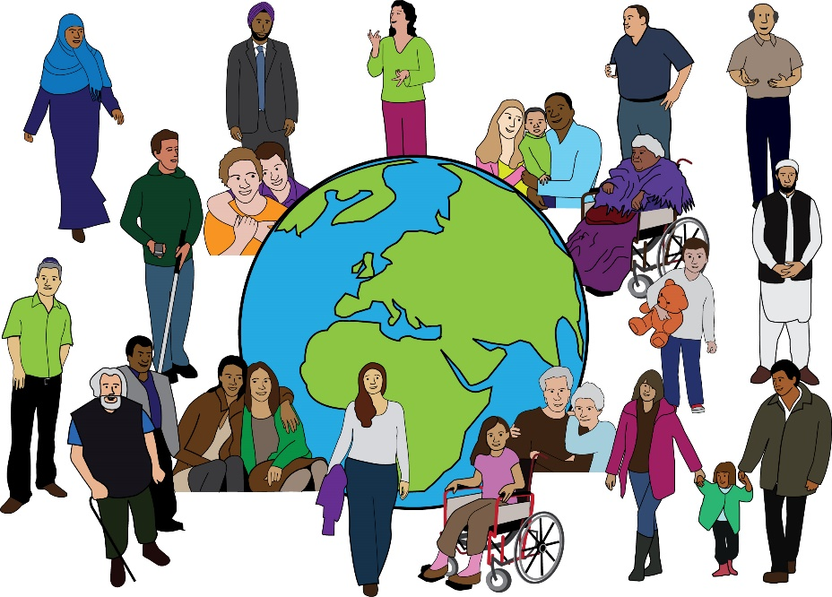

**Easy read booklet Issue**

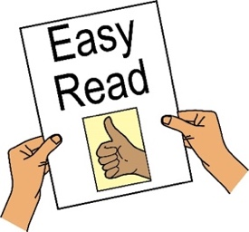

**Who we are**

We are Social Development Direct.

 We give advice to people working on **International Development** on how to include all people, such as women and people with disabilities

 **International Development** supports people around the worldwho do not have enough access to the things they need.

We work with other groups to run the Disability Inclusion Helpdesk.

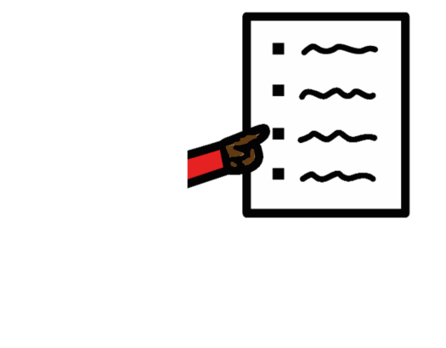This booklet is part of the **10th Helpdesk Evidence Digest.** It focuses on LGBTIQ+ people and disability inclusion.

Please look at the full report for links to documents or for more information.

Sometimes we need to use new or difficult words. These words are in bold. There is a list of what they mean at the end of the digest.

**Guest blog: Including LGBTIQ+ people with disabilities**

People with disabilities are all different. They may face unfair treatment not just because of their disability, but also because of their age, skin colour, gender, or who they love.

But there is not enough information or support for people who are both disabled and LGBTIQ+ (lesbian, gay, bisexual, transgender, intersex, queer, and more).

To talk about this, we spoke to Nu. Nu is a disability rights activist and started Revival Disability India, an online project run by and for people who are both disabled and queer.

**What problems do LGBTIQ+ people with disabilities face?**

The disability rights movement often forgets about LGBTIQ+ people. It can be mostly for straight, white, and non-disabled people.

Some people have more power and space than others. This leaves out many, like queer women and disabled people of colour.

Talking about gender or sexuality is often not seen as important in disability spaces. But it is important.

Many groups still follow an old way of helping disabled people – giving charity like ramps or wheelchairs. But they do not talk about people’s rights, identities, or feelings.

There is still a wrong belief that disabled people are not sexual. This means they do not get good education about sex and relationships.

LGBTIQ+ disabled people face many rude or personal questions, like, “how do you have sex?”

They are often not seen in films, politics, or the workplace. This makes them feel left out or not accepted.

**What can people and organisations do?**

The world is not built for LGBTIQ+ disabled people. Many places are hard to access and people face judgement.

Because of this, many create safe online groups (like WhatsApp chats or online communities). Revival Disability India is one of these.

In these spaces, people can feel safe, talk freely, and support one another.

Being kind to queer disabled people should not be seen as something special – it should be normal.

Some organisations only pretend to include queer disabled people to look good, but they do not make real changes.

Groups and companies need fair rules to stop discrimination. They also need to give disabled workers time to rest.

It is also important to understand that people face different struggles at the same time. For example, someone may be queer, disabled, and live in a village. That can be even harder.

**Helping LGBTIQ+ People with Disabilities to be included**

**What’s the issue?**

Some people are both disabled and part of the LGBTIQ+ community. This means they might face extra problems because of both their disability and their gender or sexuality. There are few services or studies that look at their lives. This makes it harder for them to get help or feel accepted.

**Important Reports and Studies**

**1**. **United Nations and disability rights**

A 2022 paper looked at a law called the Convention on the Rights of Persons with Disabilities (CRPD). It says disabled people can face more unfair treatment. But the law does not say much about gender, sexuality, or being intersex. The paper says governments and the UN should listen more to LGBTIQ+ disabled people when making laws.

**2. “Out of the Margins” report**

This report from 2020 said that people who are both LGBTIQ+ and disabled face more barriers in life. These include unfair treatment and lack of services, especially in rural areas. It calls for better training, more awareness, and laws that protect these people.

**3. Young, disabled, and LGBT+ book**

This 2020 book shares stories of young people who are both LGBTIQ+ and disabled. It says many feel invisible, even within LGBTIQ+ spaces. The book encourages support from families and communities.

**4. Podcast: “What’s Up WID”**

This podcast talks to an LGBTIQ+ disabled person who is helping build safe online communities. It shows how important it is to have places where these people feel welcome.

**5. People with intellectual disabilities**

A 2022 review found that LGBTIQ+ people with intellectual disabilities often face unfair treatment in care services. Staff do not always know how to support their gender or sexuality. More training is needed.

**6. Older LGBTIQ+ people in South Africa**

A study found that older LGBTIQ+ people, especially Black women, have a hard time getting care because of sexism and racism. The study says care services must support them better.

**7. Trans people with disabilities in the U.S.**

Trans people with disabilities often miss out on healthcare. A study says this is because they face extra discrimination. The study calls for more understanding and better data.

**8. ID documents in New Zealand**

A 2022 study found that when trans and non-binary people cannot change their gender on ID documents, it harms their mental health. Fixing this can help them feel safer and happier.

**9**. **Easy-read guide**

An organisation called CHANGE made a simple guide to help LGBTIQ+ people with autism, learning disabilities, or mental health issues understand their rights.

Education

**10. Sex education for blind students**

A 2021 study showed that sex education often leaves out LGBTIQ+ issues and disabled people. Teachers need better lesson plans that include everyone and treat all students with respect.

**11. Equality in language classes**

A project in Indonesia and Vietnam involved students in classroom debates about equality. A study on that work found that after the lessons, students were more accepting of people with disabilities and LGBTIQ+ people.

**Other topics on disability inclusion**

**12. Making things accessible**

The World Bank says making places, transport, and information accessible is very important. If people cannot access things, they cannot be fully included in society.

**13. Assistive technology**

A 2022 report says over 2.5 billion people need assistive tools (like hearing aids or wheelchairs). Many do not get them. The report gives advice on how to improve access around the world.

**14. Climate change**

Climate change is worse for disabled people. A 2022 study found they are four times more likely to die in natural disasters. The study says governments must include disabled people in planning.

**15. Climate programmes in Indonesia**

A study found that when disabled people help design climate programs, it works better. They have ideas that can help everyone.

**16. Women with disabilities leading climate action**

At a big UN meeting, women with disabilities spoke about how they are helping fight climate change and protect their communities.

**Big disability meeting (COSP15)**

In June 2022, countries met at the UN to talk about disability rights. Topics included:

Using technology to help disabled people

Helping disabled people get jobs and start businesses

Making sure disabled people are safe during disasters and climate change

There were easy-read notes and videos for everyone to understand.

**Other Important topics**

**17. A Book on inequality**

A book called Embodied Inequality says that listening to disabled people is key to making development fairer for all.

**18. Staying safe (Safeguarding)**

Two small guidebooks were made to help organisations protect disabled people from harm. These include risks at work and in community programmes.

**19. Ukraine war and disability**

During the war in Ukraine, many children with disabilities were left behind in orphanages. A report said that they were not treated fairly and need more support.

**New policies and government work**

**20. India’s new disability policy**

The Indian government shared a draft of a new policy and asked for people’s opinions in July 2022.

**21. UK’s Disability Rights Plan**

In February 2022, the UK released a new plan. It wants all disabled people to have the same rights as others and be included in every part of life.